As per the information you have entered till now, it appears that you are facing a very natural reaction to the stressful situation. If one can manage this reaction properly, it usually does not lead to emotional trauma. That is why, at this moment, you do not need an emotional first-aid. Following the problem-solving steps given here should be useful for you. If, after following these steps systematically, you still find yourself experiencing emotional pain, please consult some mental health professional.

Problem Solving Steps:

1. First you should have clear and detailed understanding of your problem. For this you may ask questions like ‘what, why, when, where, why, who, how’ to the problem situation.
2. After that, make an extensive list of the solutions to your problem situation. You may discuss with others to prepare this list. But, please do not hesitate to enroll the solutions which apparently seem impossible.
3. Now, use the ‘Control Wheel’ and choose the solutions in your control from this list.

Control Wheel

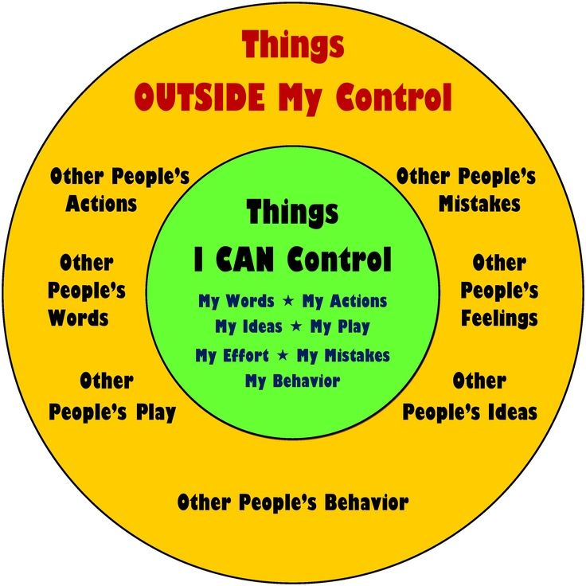

1. After that, evaluate the solutions you have selected for being in your own control with the help of ‘Cost-Benefit Chart’

Cost-Benefit Chart

|  |  |  |
| --- | --- | --- |
| Solutions | Cost | Benefit |
| 1 | A.  B.  C.  ...  ...  ...  X. | A.  B.  C.  ...  ...  ...  X. |
| 2 | A.  B.  C.  ...  ...  ...  X. | A.  B.  C.  ...  ...  ...  X. |
|  |  |  |
|  |  |  |
|  |  |  |

1. After this evaluation, select the solution which carries minimum cost to you. Please, be reminded that, there can never be a solution or decision which is not associated with any sort of risk.
2. Now, implement the solution you have chosen.
3. If the solution works to reduce your emotional pain, congratulate yourself! Even if it does not work you should appreciate yourself for the efforts you have taken! Please, do ask for professional help from a mental health professional if needed.